*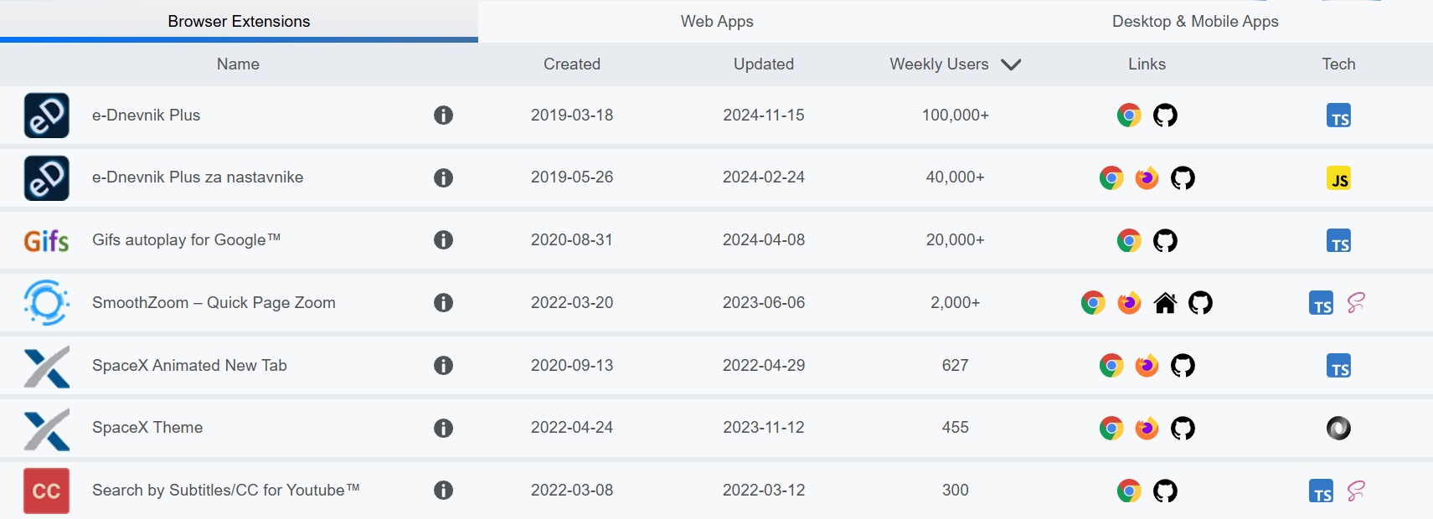*

*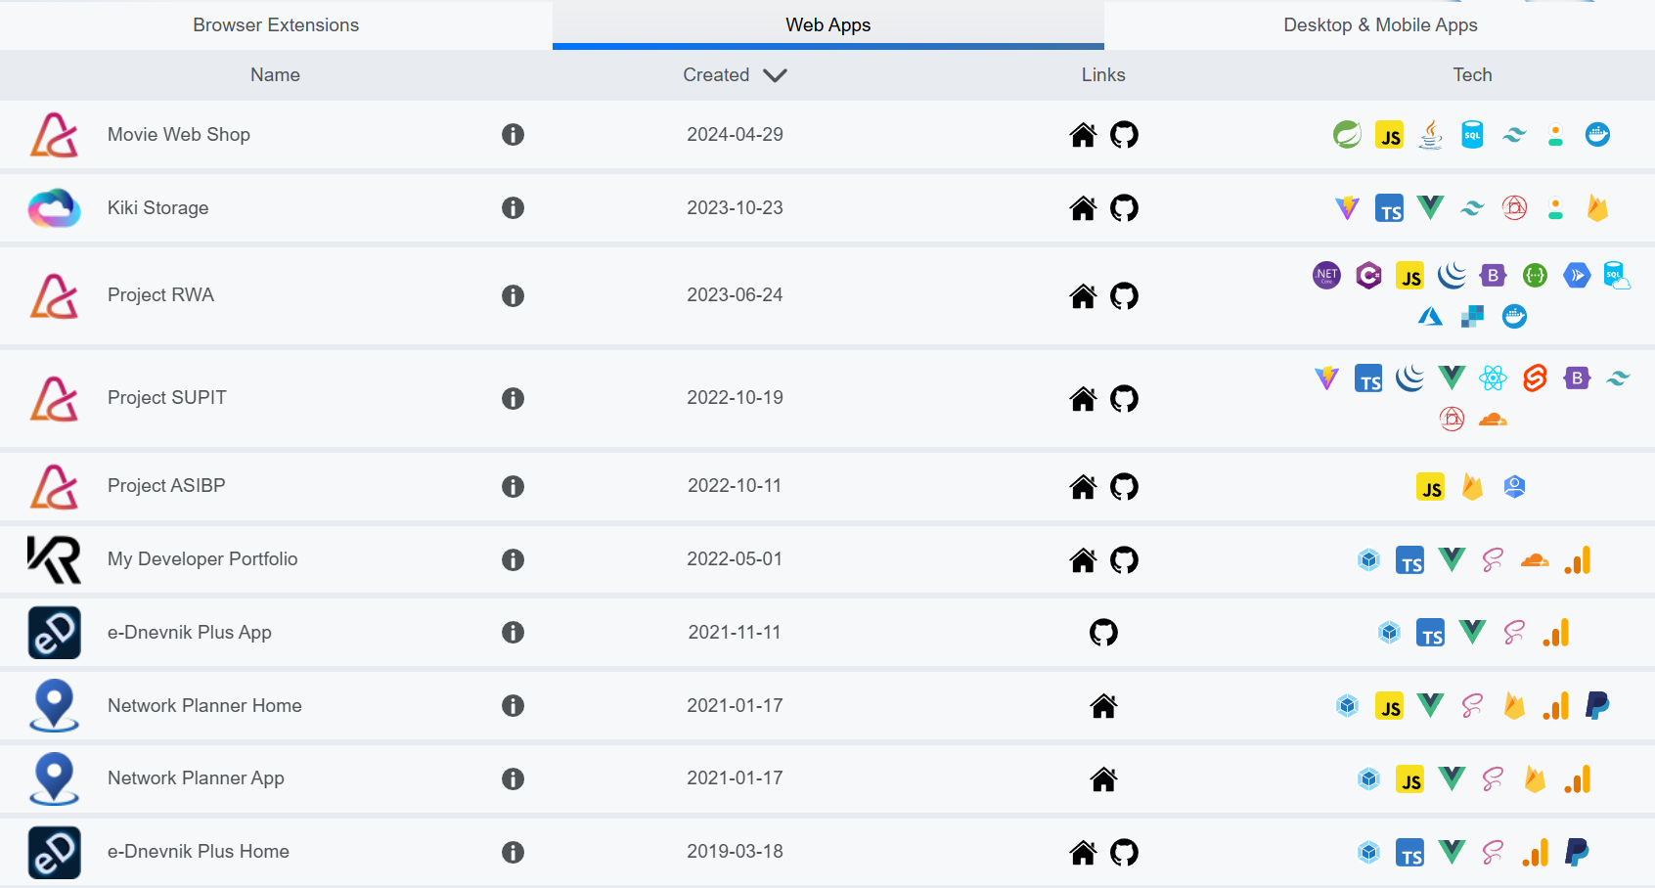*

**

*Screenshot: k1k1.dev (osobni projekti)*